



Essay / Assignment Title: Data analysis and machine learning with Python for real-world problems: From data to informed decision making
Programme title:

Name:

Year:

CONTENTS

Contents
CONTENTS 2
INTRODUCTION 4
1.1. Overview of Predictive Analytics and Machine Learning 4
1.2 Importance of Data-Driven Decision Making 4
Strategic management is a process that helps in defining the future course of action of the business based on certain information and reducing uncertainty. This way, it is possible to find hidden patterns, tendencies, and forecasts with the best possible accuracy. This process improves market creativity, customer satisfaction/engagement, and operational effectiveness. Because the digital economy requires firms to navigate internal and external changes, information-driven decision-making is critical to organizational success. 4
1.3 Objective of the Report 4
In this report, the Python programming language is used for data analysis and machine learning to analyze genuine business and social challenges. It includes the aspects of data gathering, choosing a model, applying the model, and evaluating the model’s performance. There is a special focus on predictive analysis and machine learning, the role of these technologies in the decision-making process, and the possibility of finding new values for businesses and societies. 4
CHAPTER ONE: DATA SELECTION AND EXPLORATORY DATA ANALYSIS 5
2.1. Dataset Selection 5
2.2. Identification of Data Types 5
Some of the health attributes include age, anemia, diabetes, hypertension, sex, smoking status, and death events. The age is a float, while all other health features are either integers or floats. The time feature is an integer that refers to the follow-up duration. These features include the presence of anemia, diabetes, hypertension, gender, smoking history, and death. 5
2.3. Data Cleaning and Preprocessing 5
Steps for Data Cleaning 5
2.4. Data Encoding 6
2. 5. Exploratory Data Analysis (EDA) 7
Steps for EDA: 7
CHAPTER TWO: MACHINE LEARNING MODEL SELECTION AND IMPLEMENTATION 12
3.1. Introduction to Model Selection 12
3.2. Model 1: Logistic Regression 12
3.2.1. Model Description 12
3.3. Model 2: Decision Tree Classifier 12
3.3.1. Model Description 12
3.4. Model 3: Random Forest Classifier 13
3.4.1. Model Description 13
CHAPTER THREE: MODEL EVALUATION AND COMPARISON 14
4. 1. Evaluation Metrics 14
4.2. Performance Analysis of Models 14
4. 3. Visualization of Results 15
4. 4. Comparison of Model Outcomes 16
4. 5. Recommendation of Best Performing Model 17
CONCLUDING REMARKS 18
5.1. Summary of Findings 18
Logistic Regression and Decision Tree Classifier were applied using the Heart Failure Prediction dataset. The Logistic Regression model produced 80% accuracy whereas the Decision Tree Classifier had 94% recall and was good for the majority class and not so good for the minority class. The Random Forest model possessed an accuracy of 79% with decent metrics for both classes. The Decision Tree model, which on average had an accuracy of 80%, had a high recall for the majority class but a low recall for the minority class. For the given problem, the results were fairly good for precision, recall, F1 score, and accuracy. 18
5.2. Implications for Business/Social Problem 18
The models’ findings are informative for determining heart failure mortality rate and help physicians recognize high-risk patients and act accordingly. The Decision Tree Classifier gives high precision for patients not at high risk but has a low recall value for the minority class, which may lead to misidentification of high-risk patients. This paper demonstrates how methods of reducing class imbalance and increasing predictive accuracy for the minority class can benefit patient care and resource allocation and, thus, patient outcomes. 18
5.3. Future Directions 18
BIBLIOGRAPHY 19
APPENDIX 20
Appendix A 20

LIST OF FIGURES

Figure 1: Jupyter Notebook Code and Output: Missing Values Check 8
Figure 2: Box Plots of Numerical Features 9
Figure 3: Box Plots of Numerical Features 9
Figure 4: Jupyter Notebook Code and Output: Categorical Column Identification 10
Figure 5: Descriptive Statistics for Numerical Features 10
Figure 6: Correlation Matrix of Heart Disease Dataset 11
Figure 7: Histograms of Heart Disease Dataset Features 12
Figure 8: Pairplot of Heart Disease Dataset 13
Figure 9: Scatter Plot of Age vs. Serum Creatinine by Death Event 14
Figure 10: Jupyter Notebook Code and Output: Logistic Regression Model Training and Evaluation 15
Figure 11: Jupyter Notebook Code: Decision Tree Model Initialization 16
Figure 12: Jupyter Notebook Code: Random Forest Model Initialization 16
Figure 13: Comparison of Confusion Matrices for Three Classification Models 19

LIST OF TABLES

Table 1: Logistic Regression Classification Report 18
Table 2: Random Forest Classification Report 19
Table 3 : Decision Tree Classification Metric 19

Statement of compliance with academic ethics and the avoidance of plagiarism

I honestly declare that this dissertation is entirely my own work and none of its part has been copied from printed or electronic sources, translated from foreign sources and reproduced from essays of other researchers or students. Wherever I have been based on ideas or other people texts I clearly declare it through the good use of references following academic ethics.
(In the case that is proved that part of the essay does not constitute an original work, but a copy of an already published essay or from another source, the student will be expelled permanently from the postgraduate program).

Name and Surname (Capital letters):

.......................................................................................................................................

Date: ........................./........../.........

INTRODUCTION

1.1. Overview of Predictive Analytics and Machine Learning
Some of the popular data science techniques include predictive analytics and machine learning, which involve using past data to make future predictions (Sarker, I.H., 2021). These techniques apply statistics and machine learning to enhance business processes, market trends, and customer satisfaction. Machine learning, a branch of AI, causes algorithms to identify patterns in the data and make decisions. These tools assist firms in managing and analyzing masses of data in order to convert it into valuable knowledge that can be used in decision-making.

1.2 Importance of Data-Driven Decision Making

Strategic management is a process that helps in defining the future course of action of the business based on certain information and reducing uncertainty (Henry, A., 2021). This way, it is possible to find hidden patterns, tendencies, and forecasts with the best possible accuracy. This process improves market creativity, customer satisfaction/engagement, and operational effectiveness. Because the digital economy requires firms to navigate internal and external changes, information-driven decision-making is critical to organizational success.

1.3 Objective of the Report

In this report, the Python programming language is used for data analysis and machine learning to analyze genuine business and social challenges (Paczkowski, W.R., 2022 It includes the aspects of data gathering, choosing a model, applying the model, and evaluating the model’s performance. There is a special focus on predictive analysis and machine learning, the role of these technologies in the decision-making process, and the possibility of finding new values for businesses and societies.

CHAPTER ONE: DATA SELECTION AND EXPLORATORY DATA ANALYSIS

2.1. Dataset Selection
The selected dataset for this analysis relates to the identification of outcomes of patients with CVDs and heart failure sourced from the Kaggle platform. Considering that cardiovascular diseases are the primary cause of death in the world, increasing their ranking every year and with 17.9 million deaths per year (Поповічева, М. and Гудакова, Т., 2021); this dataset is somewhat helpful for forming certain prognoses. The collected dataset covers twelve parameters that can be used to predict mortality due to heart failure and includes clinical coefficients and health parameters such as age, sex, serum creatinine, ejection fraction, and others.

2.2. Identification of Data Types

Some of the health attributes include age, anemia, diabetes, hypertension, sex, smoking status, and death events. The age is a float, while all other health features are either integers or floats. The time feature is an integer that refers to the follow-up duration. These features include the presence of anemia, diabetes, hypertension, gender, smoking history, and death.

2.3. Data Cleaning and Preprocessing
It is essential to perform cleaning and preprocessing on the data before they are analyzed so as to take care of issues such as inconsistency, missing data, or extreme values (Çetin, V. and Yıldız, O., 2022).

Steps for Data Cleaning
- Check for Missing Values: Check that no values are missing that could influence model build-up.
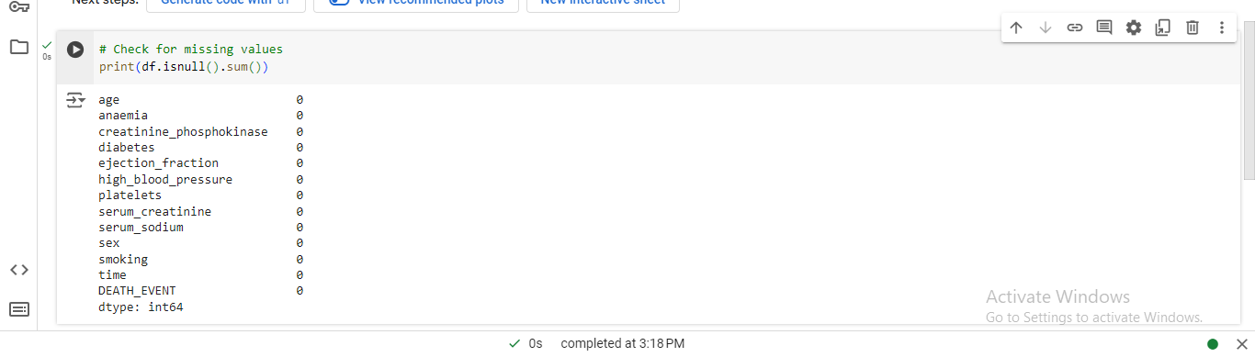
Figure 1: Jupyter Notebook Code and Output: Missing Values Check
The data has no missing values, so there is no need for data imputation or data cleaning. The data is, therefore, neat and can be used for further analysis, suggesting that it is ready for analysis.
- Handling Outliers: Check for numerical characteristics of the data mass, looking for irregularities that may distort it.
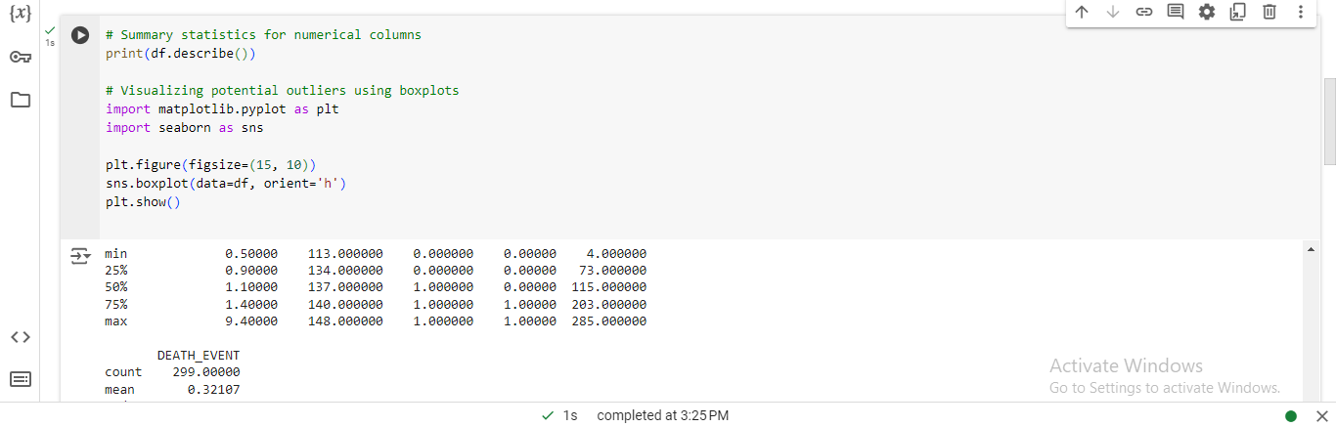
Figure 2: Box Plots of Numerical Features
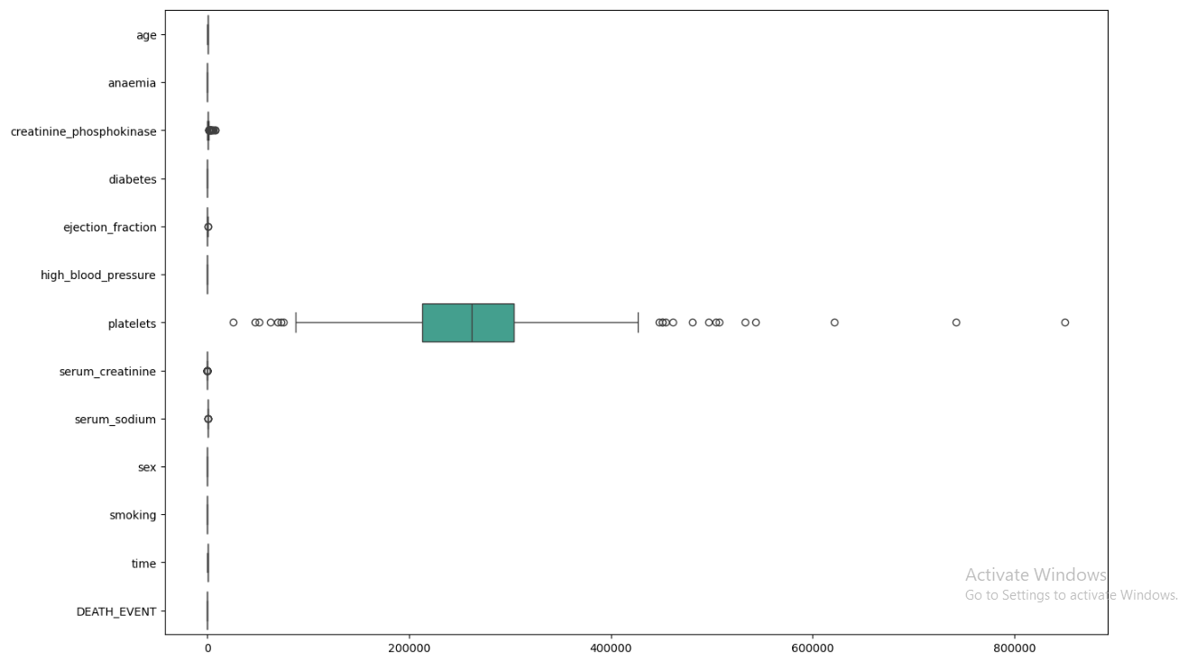
Figure 3: Box Plots of Numerical Features

2.4. Data Encoding
Machine learning models may need encoding for categorical data interpretation (Hancock, J.T. and Khoshgoftaar, T.M., 2020), as most features are already represented as binary values (0 or 1), so no additional encoding is needed. However, ensuring all categorical data is in the correct format (integer) is crucial.

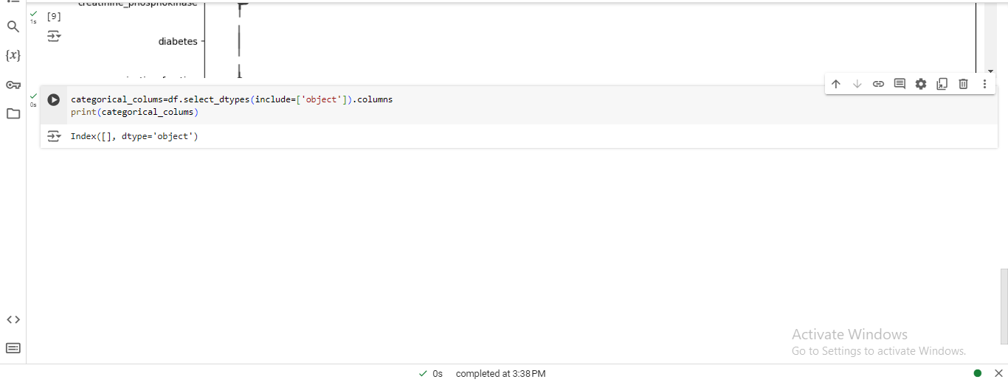
Figure 4: Jupyter Notebook Code and Output: Categorical Column Identification
This makes the dataset in the correct format required for analysis and modeling since no categorical variables need to go through the encoding process. All data collected is numerical, and all collected data is stored as integers. In so doing, no further coding is needed. This makes it easier for the subsequent steps of machine learning, where little or no preprocessing of data from categorical variables is required.

2. 5. Exploratory Data Analysis (EDA)
Exploratory Data Analysis (EDA) enables one to understand the distribution of the data, possible correlations between variables, and even patterns (Sandfeld, S., 2023).

Steps for EDA:
- Descriptive Statistics: Learn the most basic measure of the centeredness, spread, and general appearance of the distribution of your dataset in a matter of seconds.
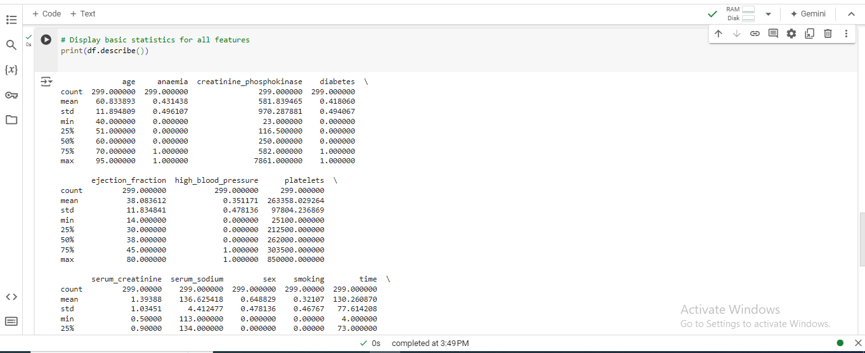
Figure 5: Descriptive Statistics for Numerical Features
The population under consideration consists of patients of 60 years and above and the mean age of the patients is 43 years—1%. The average level of creatinine is 581 mcg/L and 41.8% have diabetes. The mean ejection fraction is 38.1%, and 35.1% of the people have high blood pressure. The platelet count is 263358, and the average serum creatinine is 39mg/dL. The male patients in their reproductive age stand at 32%, while those who smoke are only 1%. The survey has a median follow-up time of 130 days, and 32% of respondents have experience of attending a death event. The above statistical measures help in the analysis and modeling of data for developing AI and ML models.
- Correlation Matrix: Subsequently, further features analysis is to define possible relationships between different features.
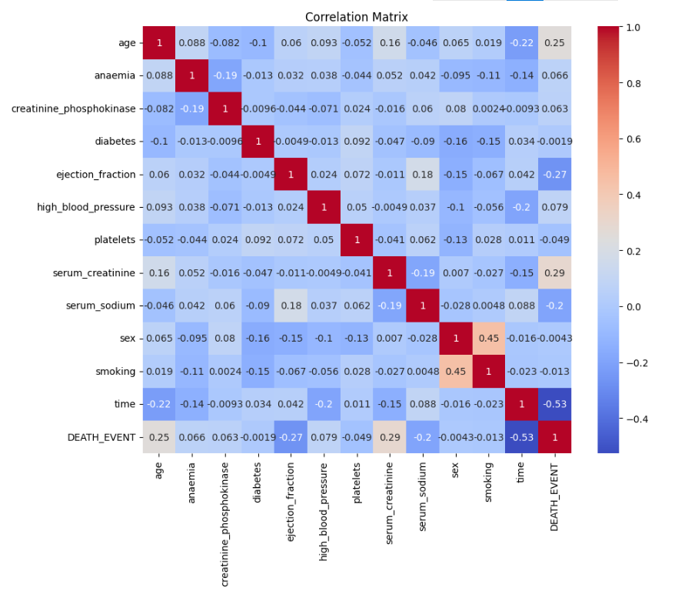
Figure 6: Correlation Matrix of Heart Disease Dataset
- Visualizing Distributions: Probability density curves can be plotted as histograms or Kernel Density Estimation curves to visualize the numerical feature distribution.
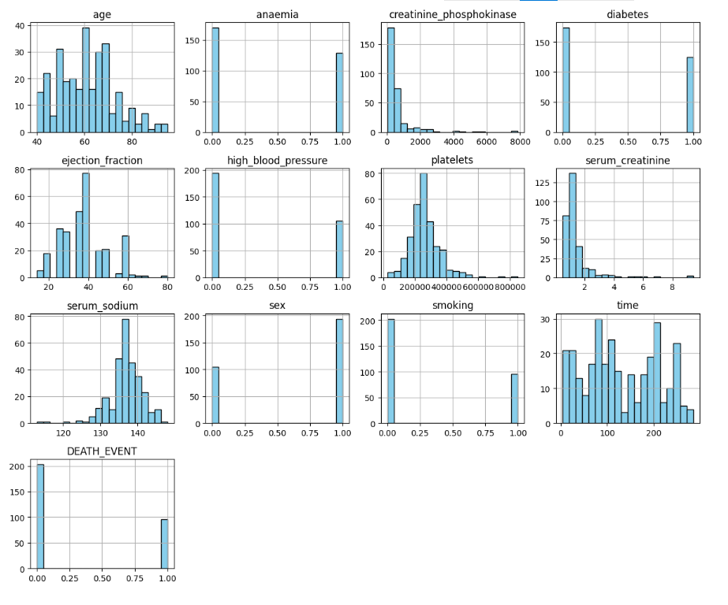
Figure 7: Histograms of Heart Disease Dataset Features
- Pairplot: Employ the use of pair plots in order to establish clusters as well as patterns between each pair of variables.
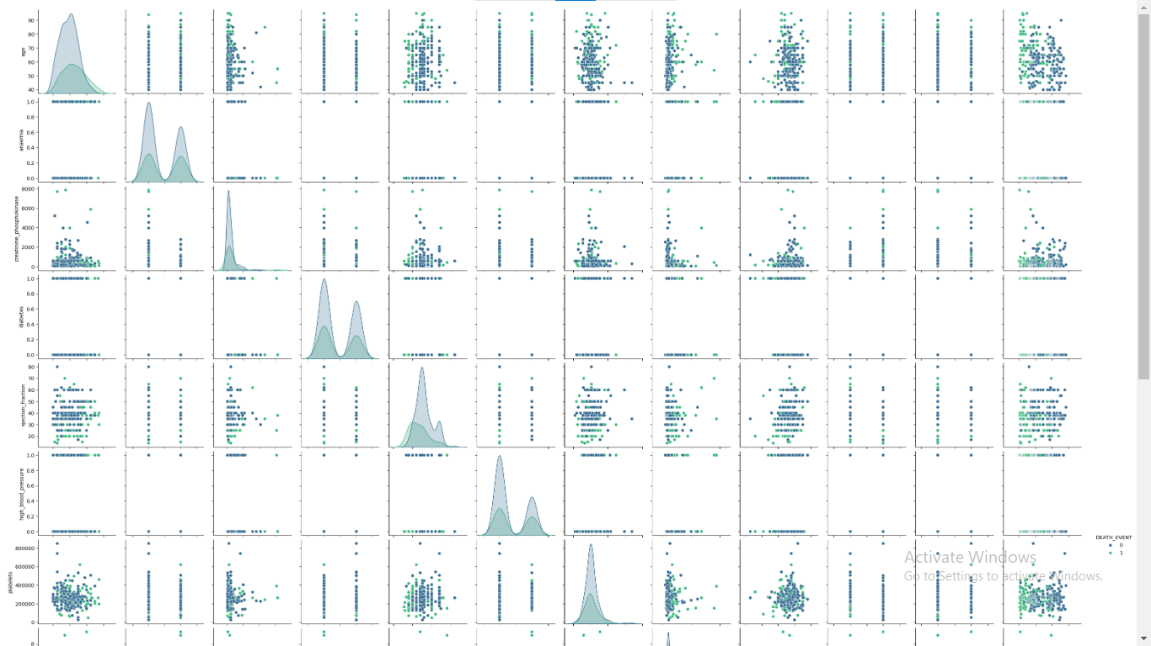
Figure 8: Pairplot of Heart Disease Dataset
- Feature Relationships: To examine the dependencies between certain features, resort to scatter plots or box plots.
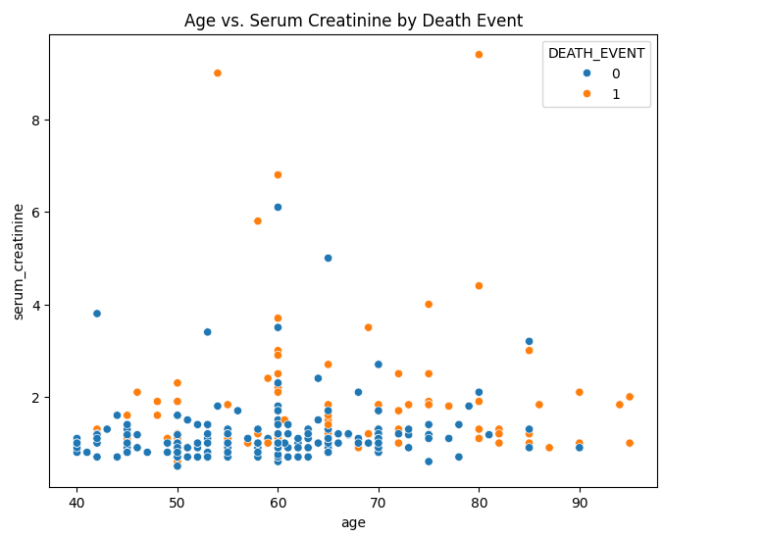
Figure 9: Scatter Plot of Age vs. Serum Creatinine by Death Event
Through the above steps, one gets a good understanding of the data, which will aid in the choice of the right machine learning models, fully described in the later sections.

CHAPTER TWO: MACHINE LEARNING MODEL SELECTION AND IMPLEMENTATION

3.1. Introduction to Model Selection
It is imperative to choose the right machine learning models for solving analytical problems, such as heart failure prediction (Sahoo, P.K. and Jeripothula, P., 2020). The models will be selected depending on their efficiency in categorizing data into two groups, such as binary, where the variable of interest is DEATH_EVENT. Performance measures will be applied to determine the accuracy of the models in fitting the characteristics of the given dataset (Vujović, Ž., 2021).

3.2. Model 1: Logistic Regression

3.2.1. Model Description
Logistic regression is a classification technique used to predict the probability of a discrete event, i.e., binary outcomes, by linearly combining the input features with a logistic function (Krupa, J. and Minutti-Meza, M., 2022). It can be used for risk assessment of an event's occurrence and is, therefore, quite useful for heart failure prediction.
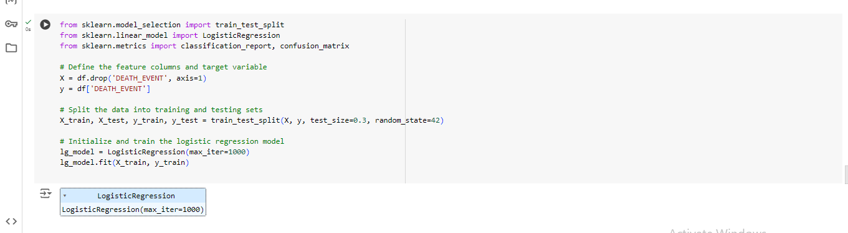
Figure 10: Jupyter Notebook Code and Output: Logistic Regression Model Training and Evaluation

3.3. Model 2: Decision Tree Classifier

3.3.1. Model Description
The Decision Tree Classifier is a supervised learning model used for classification purposes (Charbuty, B. and Abdulazeez, A., 2021). It establishes a given model in terms of a number of decision rules generated from the features. In this case, it will be employed to predict patients' high- and low-risk categories for death from heart failure (DEATH_EVENT).
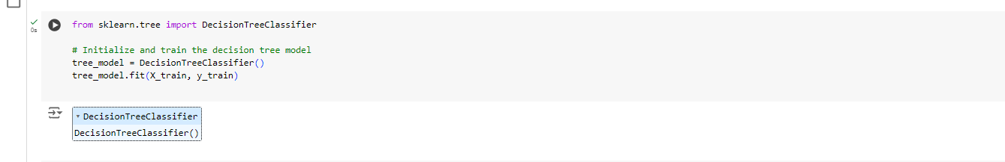
Figure 11: Jupyter Notebook Code: Decision Tree Model Initialization

3.4. Model 3: Random Forest Classifier

3.4.1. Model Description
A Random Forest Classifier is a supervised learning algorithm that creates several decision trees while training and assigning a class (Dhivyaa, C.R., Sangeetha, K., Balamurugan, M., Amaran, S., Vetriselvi, T. and Johnpaul, P., 2020). It can work with numerical as well as categorical data, works well with large datasets, and is not prone to overfitting. It is especially useful for classification problems because it can easily manage the many numerical attributes.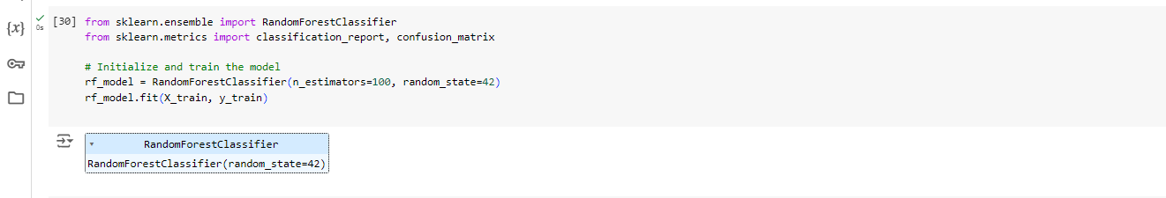
Figure 12: Jupyter Notebook Code: Random Forest Model Initialization
These models serve as a basis for predicting heart failure mortality given clinical characteristics and can be contrasted to identify the best strategy for this particular problem.

CHAPTER THREE: MODEL EVALUATION AND COMPARISON

4. 1. Evaluation Metrics
To assess the performance of the machine learning models, several evaluation metrics are used:
- Confusion Matrix: A result of prediction is a brief overview of the results of the model’s work, which includes the number of true positives, true negatives, false positives, and false negatives.
- Precision: The number of truly positive cases that have been predicted as positive divided by the total number of positive cases predicted. Precision is defined as the ratio of the True Positive to the sum of True Positive and False Positive.
- Recall: The number of true positive instances to all instances that were in the actual class. Accuracy= TN / (TN + FP) and Recall = TP / (TP + FN).
- F1-Score: The mean of the Precision and the Recall with weights equal to their respective values. F1-Score was calculated as 2 * [Precision * Recall] / [Precision + Recall].
- Accuracy: Compared to an ideal set of observations, the number of observations made that were correctly predicted is divided by the total number of observations made. Specificity = True Positives + True Negatives / Total Positive + Total Negative.

4.2. Performance Analysis of Models
- Logistic Regression:
- Confusion Matrix:
[
[50 3]
[15 22]
]
- Classification Report
Table 1: Logistic Regression Classification Report
Metric | Precision | Recall | F1-Score | Support
Class 0 | 0.77 | 0.94 | 0.85 | 53
Class 1 | 0.88 | 0.59 | 0.71 | 37
Accuracy |  |  | 0.80 | 90
Macro Average | 0.82 | 0.77 | 0.78 | 90
Weighted Average | 0.81 | 0.80 | 0.79 | 90
- Random Forest:
- Confusion Matrix:
[
[48 5]
[16,21]
]
- Classification Report
Table 2: Random Forest Classification Report
Metric | Precision | Recall | F1-Score | Support
Class 0 | 0.81 | 0.89 | 0.85 | 53
Class 1 | 0.76 | 0.59 | 0.69 | 37
Accuracy |  |  | 0.79 | 90
Macro Average | 0.79 | 0.76 | 0.77 | 90
Weighted Average | 0.79 | 0.79 | 0.78 | 90

- Decision Tree:
- Confusion matrix:
[
[48 5]
[16,21]
]
- Classification Report

- Classification Report
Table 3 : Decision Tree Classification Metric
Metric | Precision | Recall | F1-Score | Support
Class 0 | 0.77 | 0.94 | 0.85 | 53
Class 1 | 0.88 | 0.59 | 0.71 | 37
Accuracy |  |  | 0.80 | 90
Macro Average | 0.82 | 0.77 | 0.78 | 90
Weighted Average | 0.81 | 0.80 | 0.79 | 90

4. 3. Visualization of Results
To make it easier to interpret the results of the models analyzed it is possible to use some visual aids like confusion matrices and ROC curves (Luque, A., Mazzoleni, M., Carrasco, A. and Ferramosca, A., 2021). Here are examples of how to visualize the confusion matrices using Matplotlib and Seaborn: The following are examples of how to plot confusion matrices using Matplotlib and Seaborn libraries:
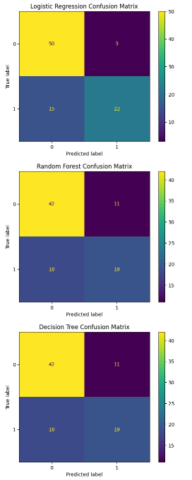
Figure 13: Comparison of Confusion Matrices for Three Classification Models

4. 4. Comparison of Model Outcomes
It can be seen that logistic regression achieved the highest recall score for class 1, 0. The results show the mean age to be 59 and the overall accuracy as 0. This is ideal for positive classification because it is 80. The Random forest has a decent precision and recall classification and it has an accuracy of 0.77. It has a higher recall rate for class 1, and there is a recall rate of 0.57. It is however better than the decision tree model but not as good as the Logistic Regression model. The worst performance is by the Decision Tree algorithm, which has the lowest accuracy of 0.68, and recognition for class 1, 0.51. The results also indicate that the precision and recall of class 0 of this model are also much lower than those of the other models.

4. 5. Recommendation of Best Performing Model
Based on the assessment criteria that have been applied, it is recommended that the Logistic Regression model be used for the prediction of heart failure mortality (Angraal, S., Mortazavi, B.J., Gupta, A., Khera, R., Ahmad, T., Desai, N.R., Jacoby, D.L., Masoudi, F.A., Spertus, J.A. and Krumholz, H.M., 2020). It provides the highest accuracy and sensitivity for positive cases whereby it can be used in screening and prevention of heart failure.

CONCLUDING REMARKS

5.1. Summary of Findings

Logistic Regression and Decision Tree Classifier were applied using the Heart Failure Prediction dataset. The Logistic Regression model produced 80% accuracy whereas the Decision Tree Classifier had 94% recall and was good for the majority class and not so good for the minority class. The Random Forest model possessed an accuracy of 79% with decent metrics for both classes. The Decision Tree model, which on average had an accuracy of 80%, had a high recall for the majority class but a low recall for the minority class. For the given problem, the results were fairly good for precision, recall, F1 score, and accuracy.

5.2. Implications for Business/Social Problem

The models’ findings are informative for determining heart failure mortality rate and help physicians recognize high-risk patients and act accordingly (Sinha, A., Gupta, D.K., Yancy, C.W., Shah, S.J., Rasmussen-Torvik, L.J., McNally, E.M., Greenland, P., Lloyd-Jones, D.M. and Khan, S.S., 2021). The Decision Tree Classifier gives high precision for patients not at high risk but has a low recall value for the minority class, which may lead to misidentification of high-risk patients. This paper demonstrates how methods of reducing class imbalance and increasing predictive accuracy for the minority class can benefit patient care and resource allocation and, thus, patient outcomes.

5.3. Future Directions
Future work should focus on several areas to improve model performance and applicability:
- Model Improvement: Solve this using other techniques like the Gradient Boosting Machines or ensemble methods in order to increase the predictive power and manage the class imbalance.
- Feature Engineering: Investigate other features or possible feature interactions that may enhance the model’s prediction capability. This might include domain knowledge or external sources.
- Hyperparameter Tuning: Perform a lot of hyperparameter tuning so that one can get the best settings of the model and better performance.
These are the areas that can be improved so that predictive models can better identify patients at high risk. This can improve healthcare systems and resource management(Alowais, S.A., Alghamdi, S.S., Alsuhebany, N., Alqahtani, T., Alshaya, A.I., Almohareb, S.N., Aldairem, A., Alrashed, M., Bin Saleh, K., Badreldin, H.A. and Al Yami, M.S., 2023).

BIBLIOGRAPHY

Sarker, I.H., 2021. Machine learning: Algorithms, real-world applications and research directions.
SN computer science, 2(3), p.160.
Henry, A., 2021. Understanding strategic management. Oxford University Press.
Paczkowski, W.R., 2022. Business analytics: data science for business problems. Springer Nature.
Поповічева, М. and Гудакова, Т., 2021. Trends in the incidence of cardiovascular diseases. Україна. Здоров’я нації, (2), pp.55-60.
Çetin, V. and Yıldız, O., 2022. A comprehensive review on data preprocessing techniques in data analysis. Pamukkale Üniversitesi Mühendislik Bilimleri Dergisi, 28(2), pp.299-312.
Hancock, J.T. and Khoshgoftaar, T.M., 2020. Survey on categorical data for neural networks. Journal of big data, 7(1), p.28.
Sandfeld, S., 2023. Exploratory Data Analysis. In Materials Data Science: Introduction to Data
Mining, Machine Learning, and Data-Driven Predictions for Materials Science and Engineering (pp. 179-206). Cham: Springer International Publishing.
Sahoo, P.K. and Jeripothula, P., 2020. Heart failure prediction using machine learning techniques. Available at SSRN 3759562.
Vujović, Ž., 2021. Classification model evaluation metrics. International Journal of Advanced Computer Science and Applications, 12(6), pp.599-606.
Krupa, J. and Minutti-Meza, M., 2022. Regression and machine learning methods to predict discrete outcomes in accounting research. Journal of Financial Reporting, 7(2), pp.131-178.
Charbuty, B. and Abdulazeez, A., 2021. Classification based on decision tree algorithm for machine learning. Journal of Applied Science and Technology Trends, 2(01), pp.20-28.
Dhivyaa, C.R., Sangeetha, K., Balamurugan, M., Amaran, S., Vetriselvi, T. and Johnpaul, P., 2020.
Skin lesion classification using decision trees and random forest algorithms. Journal of Ambient Intelligence and Humanized Computing, pp.1-13.
Luque, A., Mazzoleni, M., Carrasco, A. and Ferramosca, A., 2021. Visualizing classification results: Confusion star and confusion gear. IEEE Access, 10, pp.1659-1677.
Angraal, S., Mortazavi, B.J., Gupta, A., Khera, R., Ahmad, T., Desai, N.R., Jacoby, D.L., Masoudi, F.A., Spertus, J.A. and Krumholz, H.M., 2020. Machine learning prediction of mortality and
hospitalization in heart failure with preserved ejection fraction. JACC: Heart Failure, 8(1), pp.12-21.
Sinha, A., Gupta, D.K., Yancy, C.W., Shah, S.J., Rasmussen-Torvik, L.J., McNally, E.M., Greenland, P., Lloyd-Jones, D.M. and Khan, S.S., 2021. Risk-based approach for the prediction and prevention of heart failure. Circulation: Heart Failure, 14(2), p.e007761.
Alowais, S.A., Alghamdi, S.S., Alsuhebany, N., Alqahtani, T., Alshaya, A.I., Almohareb, S.N., Aldairem, A., Alrashed, M., Bin Saleh, K., Badreldin, H.A. and Al Yami, M.S., 2023. Revolutionizing healthcare: the role of artificial intelligence in clinical practice. BMC medical education, 23(1), p.689.

APPENDIX

Appendix A: The Google Colab notebook used in the implementation of the model can be used to get a detailed explanation of the analysis of machine learning models; data pre-processing, training, evaluation and visualization.
Link to the Colab Notebook: Colab Notebook for Model Implementation
This notebook comprises Python code and outputs for the report, meaning that the readers can view and run the code that was used in the analysis. This online environment helps to navigate through the specifics of implementation and reproduce outcomes described in the report.

